Slide 1: Bewild New Employee Onboarding
Slide 2:
Hello!
We are thrilled to welcome you to the Bewild family!
We're excited to have you join our team and are confident that your unique talents, ideas, and enthusiasm will make a meaningful impact.
Together, we'll learn, grow, and create something truly meaningful. Here's to an exciting journey ahead and many shared successes. Welcome aboard!

Slide 3: AGENDA OVERVIEW
- About Our Company
- Our Vision and Mission
- Company culture & Value
- Policies & Procedures
- Organization Structure
- Benefits and Perks

Slide 4: About Our Company
Founded in 2018, Bewild was created with a vision to redefine the way people experience food—by making it wholesome, sustainable, and deeply connected to nature.
As part of the Be-Ecoverse ecosystem, Bewild believes that food should not only nourish people but also regenerate the environment and strengthen local communities.
We work closely with farmers, producers, and local partners to promote responsible sourcing, sustainable practices, and mindful consumption. Every product and experience we create reflects our commitment to quality, transparency, and positive impact.
At Bewild, we are building more than a food brand—we are cultivating a movement that connects people with nature through food while creating lasting value for individuals, communities, and the planet.

Slide 5: The Story of Our Produce
We, the Bewild produce, come to life through
our community’s efforts in enriching soil and supporting their economic well-being.
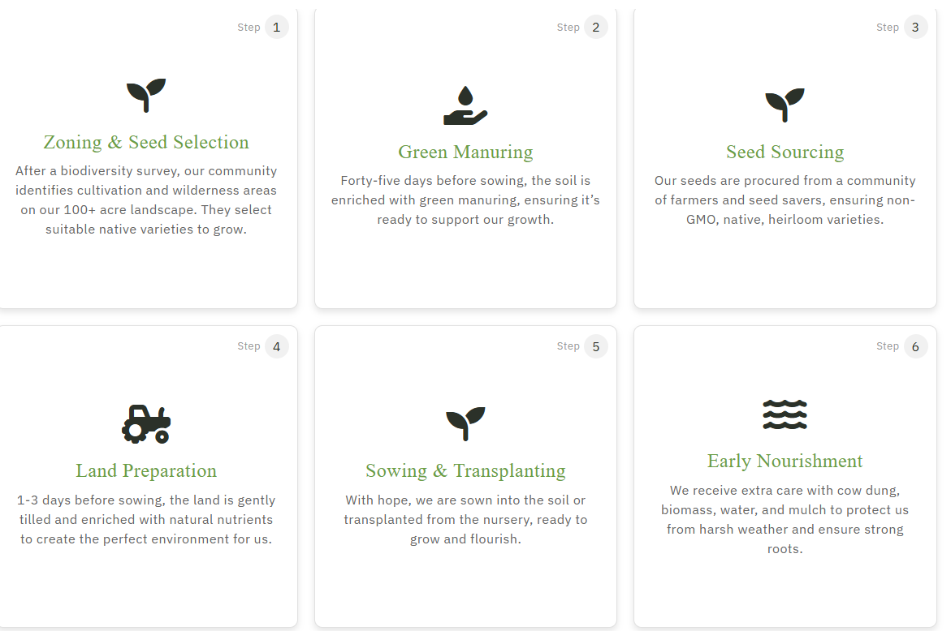

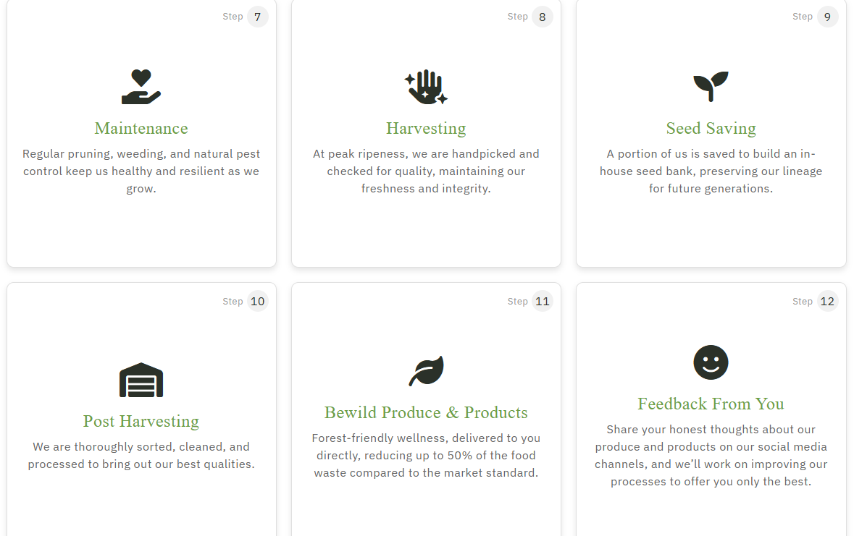
Slide 6: FOUNDER

Shruti Ajmera Reddy
CEO - Founder Bewild

Slide 7: About Bewild
Who We Are
Bewild is a purpose-driven food venture committed to creating healthy, sustainable, and locally sourced food experiences.
We believe food should:
- Nourish people
- Support local communities
- Protect nature
- Create long-term value
Our goal is not simply selling food—it is creating a better food ecosystem.

Slide 8: Our Purpose
Why We Exist
- To build a regenerative food ecosystem that positively impacts people, farmers, communities, and nature.
- To deliver wholesome food experiences while supporting local producers and sustainable practices.

Slide 9: OUR SEASONAL PRODUCE
Bewild Recipes

Slide 10: Organization Structure

Slide 11: POLICIES AND PROCEDURES

Employees should know:
- Attendance
- Leave Policy
- Working Hours
- Code of Conduct
- Travel Policy
- IT Asset Policy
- POSH Policy
- Information Security
- Performance Policy
Full policies are available in HRMS.

Slide 12: BENEFITS AND PERKS
Include your actual benefits.
Example
- Health Insurance Coverage up to ₹5 Lakhs
- ESIC (where applicable)
- Paid Leave & Leave Encashment
- Learning Opportunities
- Internal Job Opportunities
- Employee Engagement Activities
- Travel & Reimbursement
- Rewards & Recognition

Slide 13: LET'S GROW TOGETHER
We're excited to learn, build, and grow alongside you.
Questions are always welcome.

Slide 14: Thank You

